

**BRAC Online Career Hub**

Application User Manual (Phase-03)

Document Version 1.0  
28 October 2021

**Disclaimer**

This guide has been validated and reviewed for accuracy. The instructions and descriptions it contains are accurate for Phase-03 of BRAC Online Career Hub application. However, succeeding versions and guides are subject to change without notice.

**Revision History**

|  |  |  |  |
| --- | --- | --- | --- |
| Revision No. | Created/Updated By | Release Date | Comments |
| 1.0 | A S M Lutful Kabir | 28 October 2021 | 1st Release |

Table of Contents

1 About this Guide 7

2 Purpose of this Guide 7

3 Typographical Conventions 7

4 Contact Information 8

5 Solution Background – BRAC Online Career Hub 8

6 Application Channel 9

7 BRAC Online Career Hub Application 9

7.1 Application Landing Page 10

7.2 Application Registration 12

8 Admin Module 14

8.1 Admin Dashboard 14

8.2 Company Management 15

8.2.1 Create New Company 17

8.3 Role Management 19

8.3.1 Create New Role (Internal Employer) 20

8.3.2 Create New Role (External Employer) 21

8.4 User Management 22

8.4.1 Existing Employer List 22

8.4.2 Pending Employer List 23

8.4.3 Create New User (External Employer) 24

8.4.3.1 Enter User Information Details (External Employer) 25

8.4.3.2 Enter User Information Details (Internal Employer) 26

8.5 Job Management 27

8.5.1 Active Job Post 28

8.5.2 Pending Job Post 29

8.5.3 Feedback 31

8.5.4 Create Question 33

8.5.5 Feedback Response 34

8.5.6 Job Suggestion 36

9 Employer Module 37

9.1 Application Registration (External Employer) 37

9.1.1 Employer Registration Form (External) 38

9.1.2 Employer Dashboard (External) 40

9.1.3 Post New Job (External Employee) 41

9.1.3.1 Post a Job form details (External Employee) 43

9.1.4 Manage Jobs 44

9.1.4.1 Edit Job 45

9.1.4.2 Shortlisted 48

9.1.4.3 Review 49

9.1.5 View profile (External employee) 51

9.1.5.1 Account Information 52

9.1.5.2 Account Information Details 53

9.1.5.3 Contact 55

9.1.5.4 Photo 56

9.2 Internal Employer Dashboard 57

9.2.1 Chart view of number of job applications 59

9.2.2 Post New Job (Internal Employee) 60

9.2.2.1 Post a Job form (Internal Employee) 61

10 Participant Module 64

10.1 Available Jobs 65

10.1.1 Job Description 66

10.2 Jobs for Me 69

10.3 Applied Jobs 70

10.3.1 Perform Job Feedback 72

10.3.2 Shortlisted Job 73

10.4 Hot Jobs 74

**List of Tables**

Table 1: Online Career Hub Landing Page 11

Table 2 Registration Page details Login 12

Table 3: Login page details 13

Table 4 Company lists column details 16

Table 5 Company management page details 16

Table 6: Create New Company Form 18

Table 7 Role Management Page details 19

Table 8 Create New Role Form Details 20

Table 9 Create New Role Form Details 21

Table 10 Enter User Information Details (External Employer) 25

Table 11 Enter user information form details 26

Table 12 All active job post column details 28

Table 13 Pending job column details 29

Table 14 Pending job page details 30

Table 15 All Feedback Column details 31

Table 16 Feedback page details 32

Table 17 Create Question form details 34

Table 18 All Feedback Response Column details 35

Table 19 All Feedback Response Page details 35

Table 20 All list Column details 36

Table 21 Applications Registration Form Details 39

Table 22 External Employer Dashboard details 40

Table 23 Post a job form details 43

Table 24 Manage Jobs Page Details 45

Table 25 Edit job form details 47

Table 26 Shortlisted Column Details 48

Table 27 Review page column details 49

Table 28 Manage Jobs page Details 50

Table 29 Account Information Form Details 52

Table 30 Company Information Form details 54

Table 31 Contact Information Details’ 55

Table 32 Image Upload Field Details 56

Table 33 Dashboard Details 58

Table 34 Post a Job form Details (Internal Employee 63

Table 35 All Jobs Page details 65

Table 36 Job Descriptions Page details 68

Table 37 Jobs for me page details 69

Table 38 Online Applications Column Details 71

Table 39 Online Applications Page Details 71

Table 40 Shortlists Jobs page details 73

Table 41 Hot Jobs Column Details 74

**List of Figures**

Figure 1: Application Landing Page 10

Figure 2: Popular Course in Landing Page 11

Figure 3: Dynamic enrollment counts of participants & trainers 11

Figure 4: Registration Page 12

Figure 5 Login page 13

Figure 6: Admin Dashboard 14

Figure 7 Company management page 15

Figure 8: Create new comoany form 17

*Figure 9 Role Management Menu* 19

Figure 10 Create new role page (Internal) 20

Figure 11 Create new role page (External) 21

Figure 12 Admin dashboard 22

Figure 13 Existing Employer list page 22

Figure 14 Pending Employer list page 23

Figure 15 Create New User Page 24

Figure 16 Enter user information form 25

Figure 17 Eneter User Information Form 26

Figure 18 Admin dashboard 27

Figure 19 Job management page 27

Figure 20 Active Job Post (admin view) 28

Figure 21 Pendind Job Post 29

Figure 22 Feedback page 31

Figure 23 Add New Feedback question 33

Figure 24 Create Question Form 33

Figure 25 Feedback Response page 34

Figure 26 Set Job Suggestion Page 36

Figure 27 Application landing page 37

Figure 28 Employer Registration Form 38

Figure 29 External Employer Dashboard 40

Figure 30 Post a Job Form Details (1) 41

Figure 31 Post a Job Form details (3) 42

Figure 32 Post a Job Form details (2) 42

Figure 33 All jobs page 44

Figure 34 Edit Job form details (1) 45

Figure 35 Edit job Form details (2) 46

Figure 36 Edit job Form details (3) 46

Figure 37 Shortlisted Page Details 48

Figure 38 Review Page Details 49

Figure 39 Dashboard details 51

Figure 40 Account Information form details 52

Figure 41 Company Information Form Details (1) 53

Figure 42 (Company Information Form Details (2)) 53

Figure 43 Contact Details Form 55

Figure 44 Photo upload page details 56

Figure 45 Internal Employee Dishoard 57

Figure 46 Internal Employee Dashboard 58

Figure 47 chart wise details of job posts vs job applicants 59

Figure 48 Internal Employee Dashboard 60

Figure 49 Post a Job form Details (Internal Employee) (1) 61

Figure 50 Post a Job form Details (Internal Employee) (2) 62

Figure 51 Participant Dashboard 64

Figure 52 All Jobs page 65

Figure 53 All Jobs page Detail’s 66

Figure 54 Job Descriptions Page (1) 67

Figure 55 Job Descriptions Page (2) 67

Figure 56 Jobs For Me page 69

Figure 57 Online Applications Page Details 70

Figure 58 Job Feedback Form 72

Figure 59 Job Feedback Form 72

Figure 60 Shortlists Jobs Page Details 73

Figure 61 Hot Jobs Page 74

# About this Guide

This document will deliberately guide you to use every possible option/feature of Online Career Hub application’s 3rd phase in details.

# Purpose of this Guide

This document describes functional and application level features of BRAC Online Career Hub application. However, through this guide user will get conversant with application’s 3rd phase usage/working procedures.

The users/stakeholders of this application should get a rigid overview on the application’s 3rd phase through this guide.

*User*: The primary users for this application would be BRAC employees, trainers and other allotted members/users who would be categorized in the system as:

* Admin;
* Participants;
* Employer

# Typographical Conventions

|  |  |
| --- | --- |
| Type Face | Meaning |
| **Bold** | Used to indicate buttons on the screen. |
| *Italic* | Used as special instructions/actions/notes and reference to other sections. |

# Contact Information

|  |  |  |  |
| --- | --- | --- | --- |
| Name | Designation | Email | Phone |
| Nipun Ferdous | Junior Business  Analyst | nipun.ferdous@shebatech.com.bd | 01847418964 |

# Solution Background – BRAC Online Career Hub

BRAC has been working on creating a workforce through their skills development program (SDP) since 2015. It has a mission of empowering youths through skills development and decent employment so that a competent workforce can lead our nation forward. The program’s outcomes are aligned to the SDG (sustainable development goal) which would be ensuring skills for youth and adults for decent employment and entrepreneurship and SDG 8 (promoting sustained, inclusive and sustainable economic growth, full and productive employment and decent work for all).

COVID-19 pandemic has restricted the scopes of physical training. Given the government’s embargoes, the educational institutions have been remained closed since 17 March, 2020. On the other hand, nearly 25 million of the global population are anticipated to lose their jobs due to the COVID-19 crisis, according to the recent report of the International Labour Organization (ILO). A staggering increase in the unemployment rate in Bangladesh is also evident. The reasons for this sharp increase in youth unemployment are, restrictions in the new recruitment, sudden job loss and so on. Given these circumstances, skills training through digital platforms is imperative. Since the pandemic caused a massive impact of deduction from the ongoing workforce and their opportunities, the job seekers will need to be competitive in terms of increasing skill sets that would fit most appropriately with the existing market.

Phase-03 of Online Career Hub Solution will enable its users with following key capabilities:

**As an Admin**

* Create company profile;
* Create new employer role (Internal/External);
* Create new questions for portal feedback;
* Approve External employer joining request;
* Approve job post;

**As an Employer**

* Create job post;
* Manage job post;
* Create shortlist, review and select a candidate;
* Set Improvement Plan;
* Accept/Decline participants request for Improvement Plan Time Extension;

**As a Participant**

* Find available Job post;
* Category based filtered job post;
* Preference based job post search;
* Apply on specific job post Start;
* Submit feedback for applied jobs;

# Application Channel

The application will be used by intended users on their PC / Laptops via web.

# BRAC Online Career Hub Application

Through this document user will get a complete walk through over the application’s Third phase. From Below, each and every module and its underside features, relevant actions and usage criteria are depicted.

## Application Landing Page

The Landing page will provide an overall glimpse of the entire solution. Users from all roles will be able to login using their unique username and password as well as new user will be able to register to the system from this page.

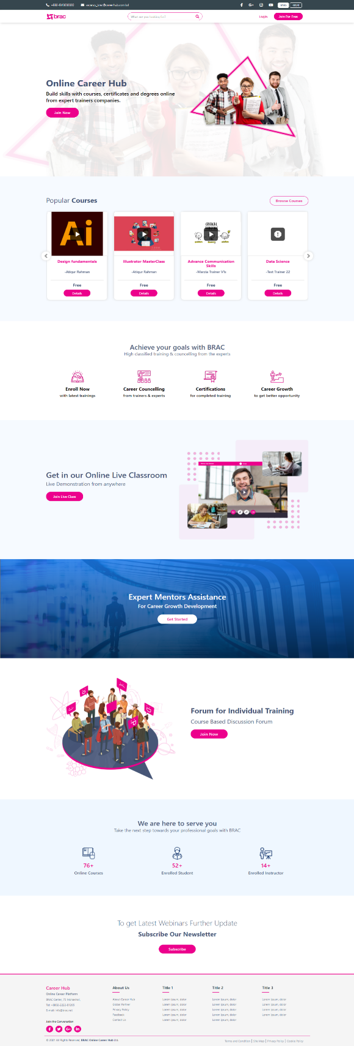

Figure 1: Application Landing Page

* The section Popular Courses will showcase the courses based on participants enrollment count.

Figure 2: Popular Course in Landing Page

* Users will be able to view online courses, enrolled instructors and participants dynamically from below section of the landing page.

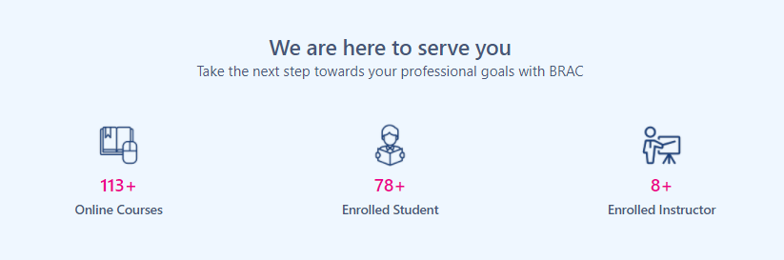

Figure 3: Dynamic enrollment counts of participants & trainers

|  |  |
| --- | --- |
| **Field**  **Name/Icon/Button** | **Description** |
|  | Click to go to the Login Page. |
|  | Clicking on **join for free** will show two drop down and clicking on any of drop down will redirect to application registration page. |
|  | Multilingual Toggle Button to interchange application interface language between Bangla and English. |

Table 1: Online Career Hub Landing Page

## Application Registration

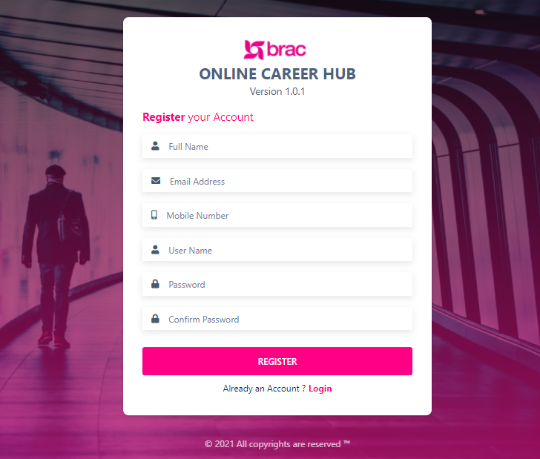

Figure 4: Registration Page

* Through this page user will be able to sign up for Online Career Hub application.

Table 2 Registration Page details Login

|  |  |
| --- | --- |
| **Field Name/Icon/Button** | **Description** |
| Full Name | Enter user full name |
| Email Address | Enter user email address |
| Mobile Number | Enter user mobile number |
| User Name | Enter user name |
| Password | Enter user password |
| Confirm Password | Re-enter / Confirm Password |
|  | After filling up all the fields above, click to register |
|  | Login for users already having an account |

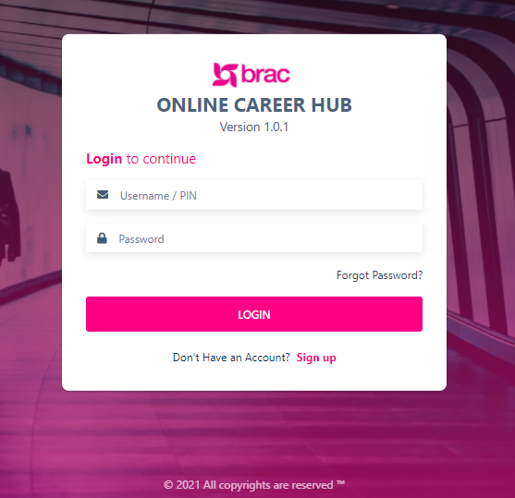

Figure 5 Login page

* Entering username/pin, password and hitting enter will let the user login to the system.

|  |  |
| --- | --- |
| **Field Name/Icon/Button** | **Description** |
| Username/PIN | Enter username/pin |
| Password | Enter Password |
|  | Hit login to enter the application |
|  | Click to sign up |

Table 3: Login page details

# Admin Module

In 3rd phase of Online Career Hub, Company list, Employer (External/Internal) role creation, External employer joining request approval, job post approval, Job feedback has been added to the Admin Module.

Company list consists of:

* List of all the company;
* The list will show Company size, category, Establishment year, Category etc.;
* Create new company;

Detail instructions on each component above are illustrated below.

## Admin Dashboard

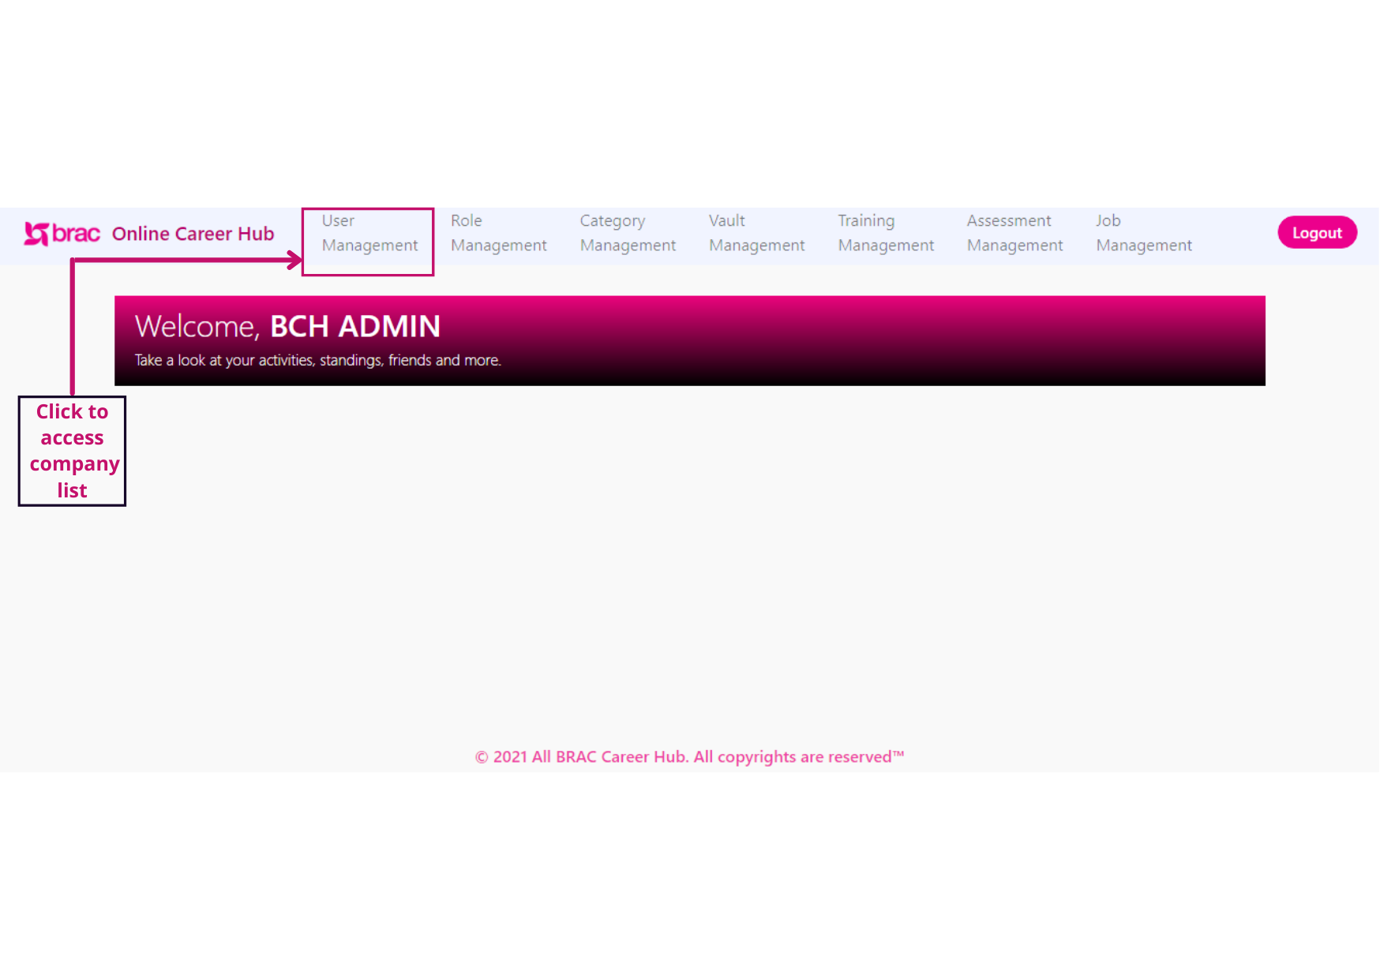

Figure 6: Admin Dashboard

## Company ManagementC:\Users\Sheba\Pictures\Company list.png

Figure 7 Company management page

* Click *User Management* to access the sub-menus
* Click User *Management* menu to access Company list
* Here we will find this sub menu’s;
  + List of All users
  + List of Zoom accounts
  + Pending Employer list
  + Existing Employer List
  + Portal Feedback
  + Feedback Response
  + Company List
  + All center
  + Counseling
  + Web seminar
* Clicking on *Company list* will show List of Company List page by default
* This page consists following columns: Company name, Company size, category, Establishment year, Country, District, Thana, status, action;
* Click to logout;

|  |  |
| --- | --- |
| **Columns /Field Name/Icon/Button** | **Description** |
| ***Company Name*** | Enter Company your company name |
| ***Company Size*** | Enter Company size |
| ***Year of Establishment*** | Enter Year of establishment |
| ***Select Country*** | Select relevant country |
| ***Select Thana*** | Select relevant Thana |
| ***Category*** | Select relevant category |
| ***Status*** | Active/ inactive status of the company |
| ***Action*** | Click to edit company details |

Here are the following column details of company lists:

Table 4 Company lists column details

Table 5 Company management page details

|  |  |
| --- | --- |
| **Field Name/Icon/Button** | **Description** |
|  | Enables admin to search for any keyword; |
|  | User can go back and forth of pages by clicking Next/Previous buttons. |
|  | User can decide to view the number of entries of total skills from this drop down list at the bottom left corner of this page. |
|  | Click to open create new company; |
|  | Click to edit a company details; |

### Create New Company

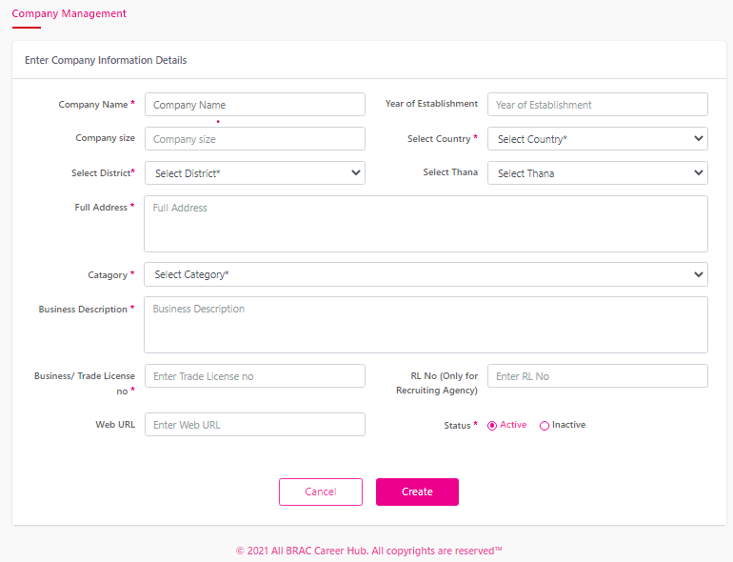

Figure 8: Create new comoany form

* Admin will Enter *Company Information’s Details* form for creating a new company;

Table 6: Create New Company Form

|  |  |
| --- | --- |
| **Field Name/Icon/Button** | **Description** |
| ***Company Name*** | Enter Company your company name |
| ***Company Size*** | Enter Company size |
| ***Year of Establishment*** | Enter Year of establishment |
| ***Select Country*** | Select relevant country |
| ***Select Thana*** | Select relevant Thana |
| ***Full Address*** | Enter the company address |
| ***Category*** | Select relevant category |
| ***Business Descriptions*** | Enter Business description |
| ***Business Trade license no*** | Enter Trade license No; |
| ***RL No*** | Enter relevant RL NO |
| ***Web URL*** | Enter Your company URL |

## C:\Users\Sheba\Downloads\Clickin (1).pngRole Management

*Figure 9 Role Management Menu*

* Click *Role Management to* access the sub-menus;
* Here we will find this column
  + Role name
  + Permission
  + Actions;

|  |  |
| --- | --- |
| **Field Name/Icon/Button** | **Description** |
| **Export (Excel)** | Click to download excel report of this page; |
|  | Enables admin to search for any keyword; |
|  | User can go back and forth of pages by clicking Next/Previous buttons. |
|  | User can decide to view the number of entries of total skills from this drop down list at the bottom left corner of this page. |
|  | Click to open create new company; |
|  | Click to edit a company details; |

Table 7 Role Management Page details

### Create New Role (Internal Employer)

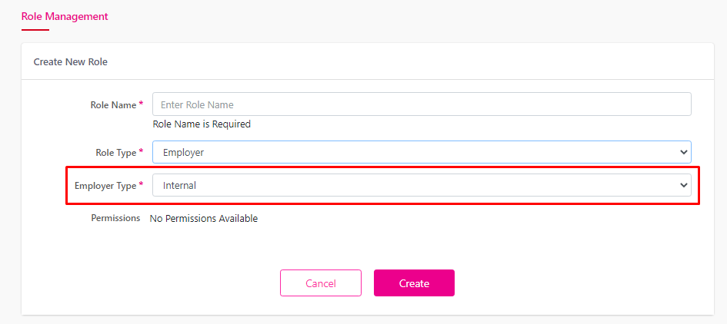

Figure 10 Create new role page (Internal)

* In this form Admin user will be able to create a role of internal Employee;

Table 8 Create New Role Form Details

|  |  |
| --- | --- |
| **Field Name/Icon/Button** | **Description** |
| ***Role Name*** | *Here enter the name of the Role* |
| ***Role Type*** | *Select Role Type from the drop down* |
| ***Employee type*** | *Select Employer Internal type from the Drop down* |

### Create New Role (External Employer)

Figure 11 Create new role page (External)

* Admin will be able to create role of external employee;

Table 9 Create New Role Form Details

|  |  |
| --- | --- |
| **Field Name/Icon/Button** | **Description** |
| ***Role Name*** | *Here enter the name of the Role* |
| ***Role Type*** | *Select Role Type from the drop down* |
| ***Employee type*** | *Select Employer External type from the Drop down* |

## User Management

Figure 12 Admin dashboard

* Clicking on *User Management* Admin will redirect to user management menu

### Existing Employer List

Figure 13 Existing Employer list page

* Clicking on *Existing Employer List* admin will find all the employer list here;

### Pending Employer List

Figure 14 Pending Employer list page

* Clicking On Pending Employer List Admin will be able to see the list of pending employer’s
* Admin can accept/reject an employer joining request from here

### Create New User (External Employer)

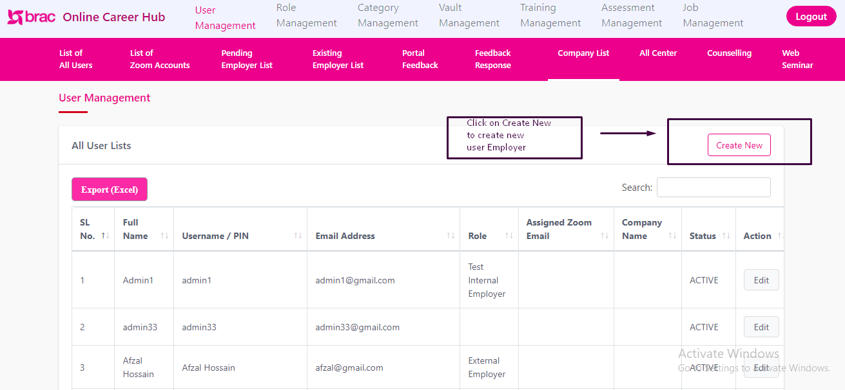

Figure 15 Create New User Page

#### Enter User Information Details (External Employer)

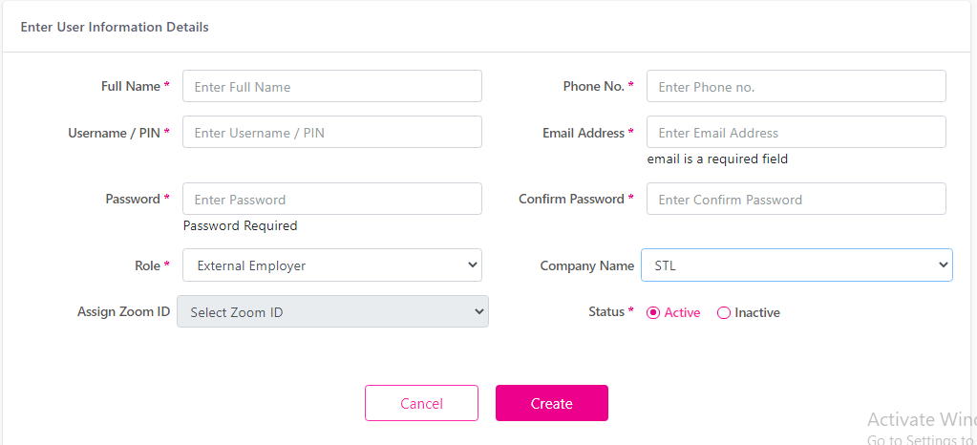

Figure 16 Enter user information form

* Admin will enter relevant user information in the form for creating a new External Employer User

Table 10 Enter User Information Details (External Employer)

|  |  |
| --- | --- |
| **Field Name/Icon/Button** | **Description** |
| ***Full Name*** | *Enter Full name of the employee* |
| ***Username/PIN*** | *Enter Pin or , Username* |
| ***Phone No*** | *Enter Phone No.* |
| ***Email Address*** | *Enter Email address of the employer* |
| ***Password*** | *Enter password for user* |
| ***Confirm Password*** | *Confirm the password of the user* |
| ***Role*** | *Select Role type External from the drop down* |
| ***Company Name*** | *Select company name from the drop down* |
| ***Status*** | *Set the active / Inactive from status* |

#### Enter User Information Details (Internal Employer)

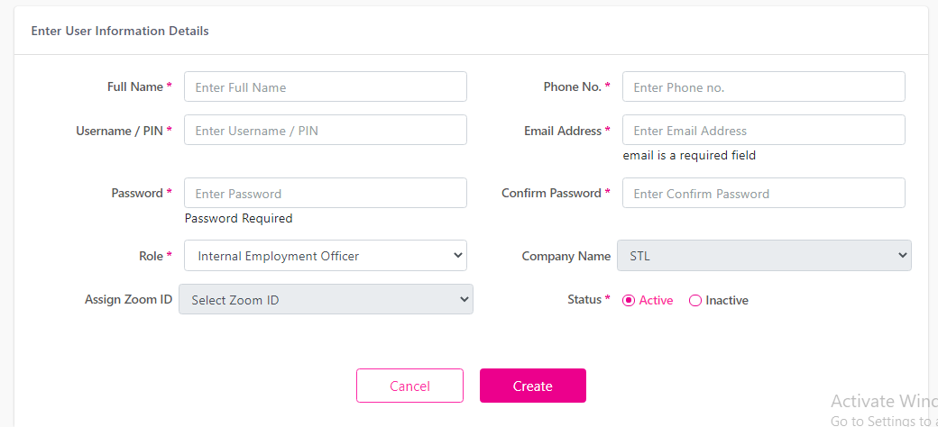

Figure 17 Eneter User Information Form

* Admin will enter relevant user information in the form for creating a new Internal Employer User

Table 11 Enter user information form details

|  |  |
| --- | --- |
| **Field Name/Icon/Button** | **Description** |
| ***Full Name*** | Enter Full name of the employee |
| ***Username/PIN*** | Enter Pin or , Username |
| ***Phone No*** | Enter Phone No. |
| ***Email Address*** | Enter Email address of the employer |
| ***Password*** | Enter password for user |
| ***Confirm Password*** | Confirm the password of the user |
| ***Role*** | Select Role type Internal from the drop down |
| ***Company Name*** | Select company name from the drop down |
| ***Status*** | Set the active / Inactive from status |

## Job Management

Figure 18 Admin dashboard

* Clicking on *Job Management Menu* from the Admin dashboard it will redirect to Job Management Sub- Menu.
* Here admin will find following sub menu’s;

1. Pending Job Post
2. Active Job post
3. Feedback
4. Job suggestion
5. Feedback response;

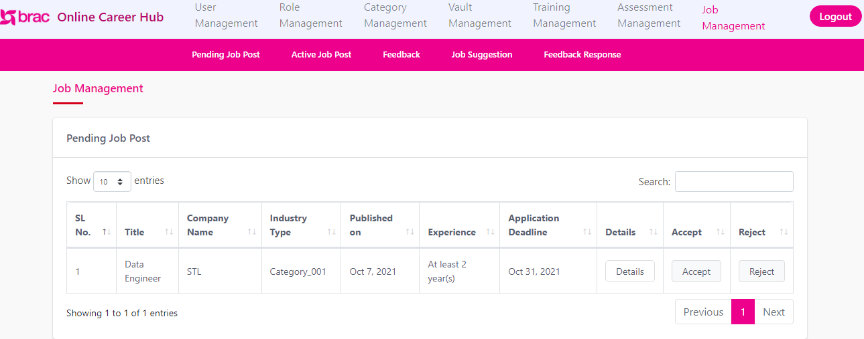

Figure 19 Job management page

### Active Job Post

Figure 20 Active Job Post (admin view)

* Clicking on *Active Job Post* sub- menu admin will be able to see all active job which was posted by the external/internal employer;
* Here admin will find the following column:
* Title
* Company Name
* Industry Type
* Published on
* Experience
* Application Deadline
* Status
* Details

Table 12 All active job post column details

|  |  |
| --- | --- |
| **Column/Field Name/Icon/Button** | **Description** |
| ***Title*** | Job post title |
| ***Company Name*** | Company title |
| ***Industry Type*** | Type of the job industry |
| ***Published on*** | Published date |
| ***Experience*** | Experience level |
| ***Application Deadline*** | Deadline of the Job post |
| ***Status*** | Active / Inactive status of the job post |
| ***Details*** | Details information of the job post |

### Pending Job Post

Figure 21 Pendind Job Post

* Clicking on *Pending Job Post* sub menu admin will be able to see all the job post request by the External employer
* Here admin will find following Column:
  + Title
  + Company Name
  + Industry Type
  + Published on
  + Experience
  + Application Deadline
  + Status
  + Details

Table 13 Pending job column details

|  |  |
| --- | --- |
| **Column/Field Name/Icon/Button** | **Description** |
| ***Title*** | Job post title |
| ***Company Name*** | Company title |
| ***Industry Type*** | Type of the job industry |
| ***Published on*** | Published date |
| ***Experience*** | Experience level |
| ***Application Deadline*** | Deadline of the Job post |
| ***Details*** | Details information about the job post |

Table 14 Pending job page details

|  |  |
| --- | --- |
| **Field Name/Icon/Button** | **Description** |
| **Export (Excel)** | Click to download excel report of this page; |
|  | Enables admin to search for any keyword; |
|  | User can go back and forth of pages by clicking Next/Previous buttons. |
|  | User can decide to view the number of entries of total skills from this drop down list at the bottom left corner of this page. |
|  | Click to accept a job post |
|  | Click to reject job post |

### Feedback

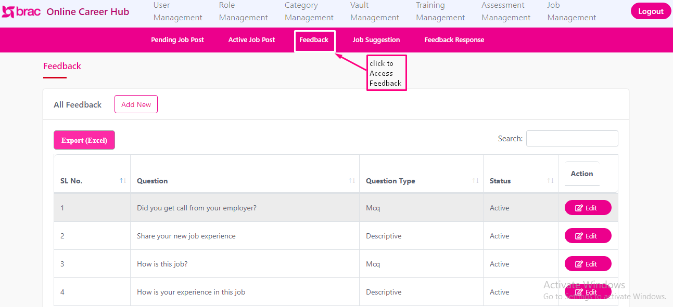

Figure 22 Feedback page

* Clicking on Feedback it will redirect to all feedback sub menu
* Here admin will be able to add new questions for job feedback
* Here admin will find following column:
* Question
* Question Type
* Status
* Action

Table 15 All Feedback Column details

|  |  |
| --- | --- |
| **Column/Field Name/Icon/Button** | **Description** |
| ***Question*** | The feedback relevant question |
| ***Question Type*** | Type of the question |
| ***Status*** | Active / Inactive status of the question |
| ***Actions*** | Edit or change the questions |

Table 16 Feedback page details

|  |  |
| --- | --- |
| **Field Name/Icon/Button** | **Description** |
| **Export (Excel)** | Click to download excel report of this page; |
|  | Enables admin to search for any keyword; |
|  | User can go back and forth of pages by clicking Next/Previous buttons. |
|  | User can decide to view the number of entries of total skills from this drop down list at the bottom left corner of this page. |
|  | Click to open create new questions; |
|  | Click to edit a question; |

### Create Question

Figure 23 Add New Feedback question

* 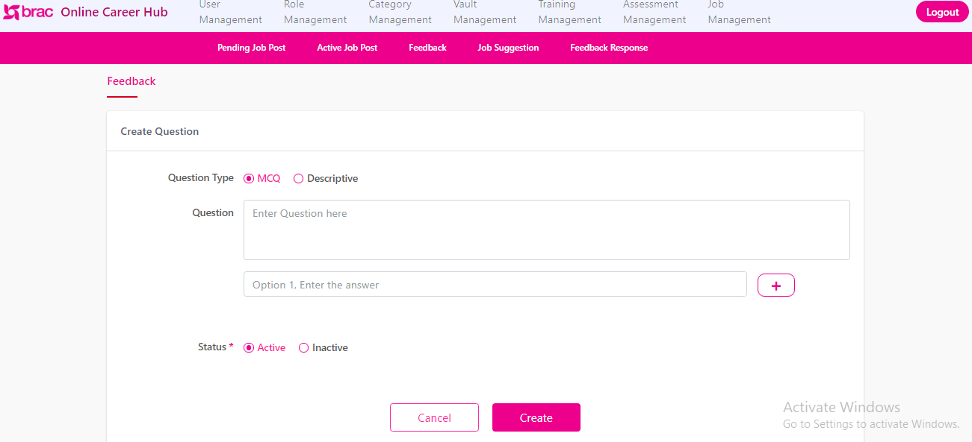Clicking on Add *new* button it will redirect to Create Question sub menu;

Figure 24 Create Question Form

* Here Admin will fill up the form with relevant information to create new question for Job feedback

Table 17 Create Question form details

|  |  |
| --- | --- |
| **Field Name/Icon/Button** | **Description** |
| ***Question Type*** | Select type from multiple/descriptive |
| ***Question*** | The relevant question for job feed |
| ***Option*** | Create options for the feedback questions |
| ***Status*** | Set the active / Inactive from status |

### Feedback Response

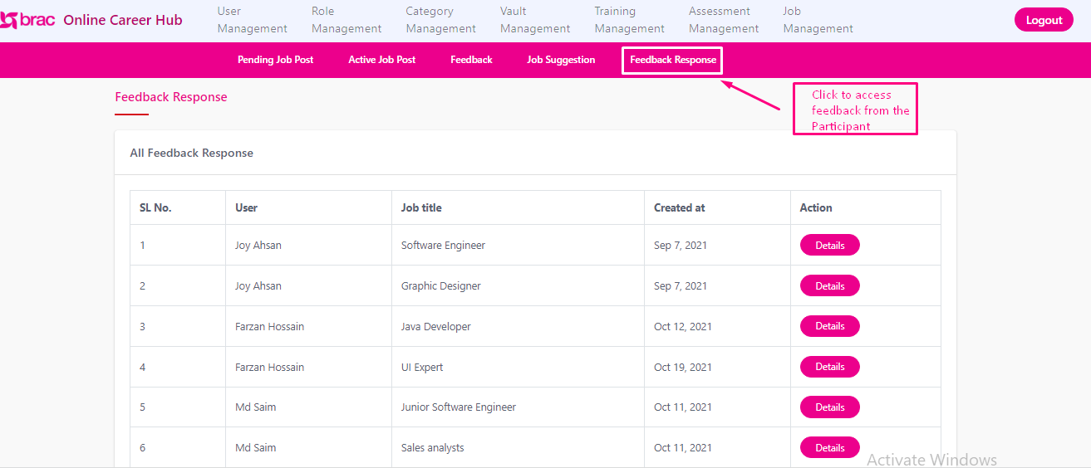

Figure 25 Feedback Response page

* Clicking on feedback response menu it will redirect admin to All Feedback Response
* Here admin will see following columns:
* User
* Job Title
* Created at
* Action

Table 18 All Feedback Response Column details

|  |  |
| --- | --- |
| **Column/Field Name/Icon/Button** | **Description** |
| ***User*** | Name of the user |
| ***Job title*** | Title of the relevant job |
| ***Created at*** | Date of the feedback response of the user |
| ***Action*** | Click to see the details of the feedback response |

Table 19 All Feedback Response Page details

|  |  |
| --- | --- |
| **Field Name/Icon/Button** | **Description** |
| **Export (Excel)** | Click to download excel report of this page; |
|  | Enables admin to search for any keyword; |
|  | User can go back and forth of pages by clicking Next/Previous buttons. |
|  | User can decide to view the number of entries of total skills from this drop down list at the bottom left corner of this page. |
|  | Click to see the response details; |

### Job Suggestion

Figure 26 Set Job Suggestion Page

* Clicking on job suggestion it will redirect to all list of job suggestion sub menu.
* Here admin will find following column:
* Participant Info
* Job Post info
* Actions

Table 20 All list Column details

|  |  |
| --- | --- |
| **Column/Field Name/Icon/Button** | **Description** |
| ***Participant Info*** | Relevant Participant information for job suggestion |
| ***Job Post Info*** | Relevant job post information about job suggestion |
| ***Action*** | Admin user can select any of the two option between active/ Inactive. |

# Employer Module

In application’s 3rd phase Employee will be able to:

* Access Live job section;
* Access Job Applications section;
* Access Shortlisted Candidate section;
* Access Review section;
* Access Post New job section
* Access Manage jobs;

Including above, all the other correlated features are dissected and described below.

## Application Registration (External Employer)

Figure 27 Application landing page

* This is the Application landing page for the external employer;
* Clicking on Employer user will redirect to employee registration form

### Employer Registration Form (External)

Figure 28 Employer Registration Form

Table 21 Applications Registration Form Details

|  |  |
| --- | --- |
| ***Field Name/Icon/Button*** | **Description** |
| ***User Name*** | Relevant user name of the employee user |
| ***Password / Confirm Password*** | Enter user desired password , again confirm the password |
| ***Company Name*** | Enter company name |
| ***Year of Establishment*** | Year of establishment of the company |
| ***Company Size*** | Size Of the company |
| ***Select country*** | Country of the company |
| ***Select District*** | District of the company |
| ***Select Thana*** | Thana of the company |
| ***Full address*** | Relevant Address of the company |
| ***Select Category*** | Relevant category of the company |
| ***Business Description*** | Business description of the company |
| ***License No*** | License no of the company |
| ***Rl No*** | Relevant Rl no of the company |
| ***Website URL*** | URL of the Company |
| ***Contact Person Name*** | Name of the contact person |
| ***Contact Persons Designation*** | Relevant designation of the contact person |
| ***Email Address*** | Email address of the employer |
| ***Mobile Number*** | Relevant phone number of the External employer |

### Employer Dashboard (External)

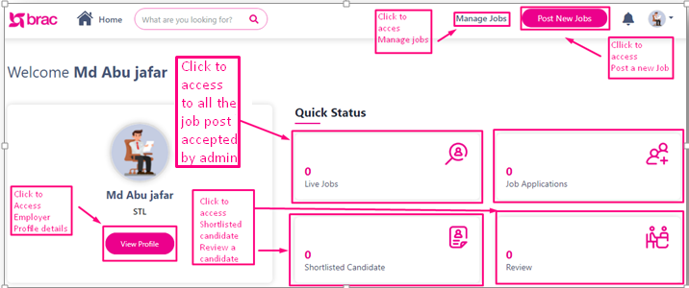

Figure 29 External Employer Dashboard

* This is the dashboard of an External Employee user;
* User will Find following this Card view, menu’s , buttons on the dashboard:
* Live Jobs
* Shortlisted Candidate,
* Review.
* View Profile

Table 22 External Employer Dashboard details

|  |  |
| --- | --- |
| **Field Name/Icon/Button** | **Description** |
| ***Live Jobs*** | Here user will find list of all posted job list which are live at that moment |
| ***Shortlisted candidate*** | Here user will find Shortlisted candidate |
| ***Review*** | Here user will find reviewed candidate |
| ***View profile*** | Here user will find the user profile details |

### Post New Job (External Employee)

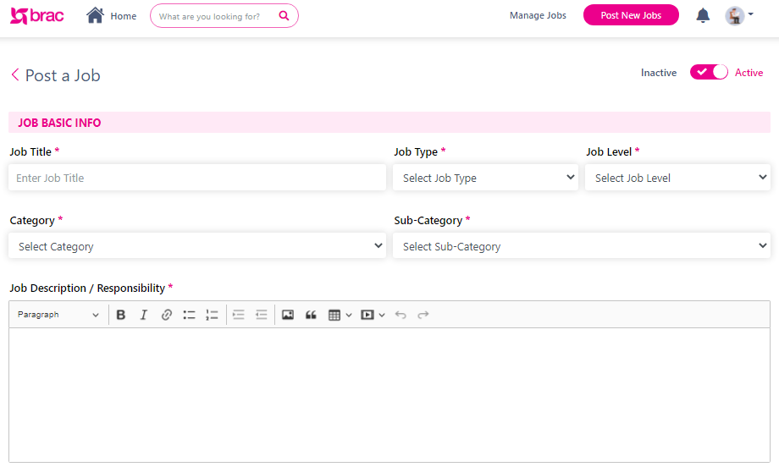

Figure 30 Post a Job Form Details (1)

* User have to enter relevant information in the form to post a job
* Clicking on Post New Jobs user will redirect to post a job form;

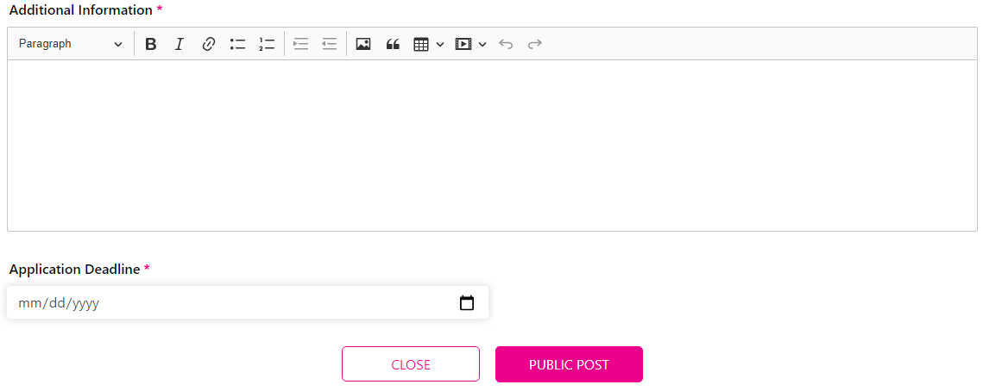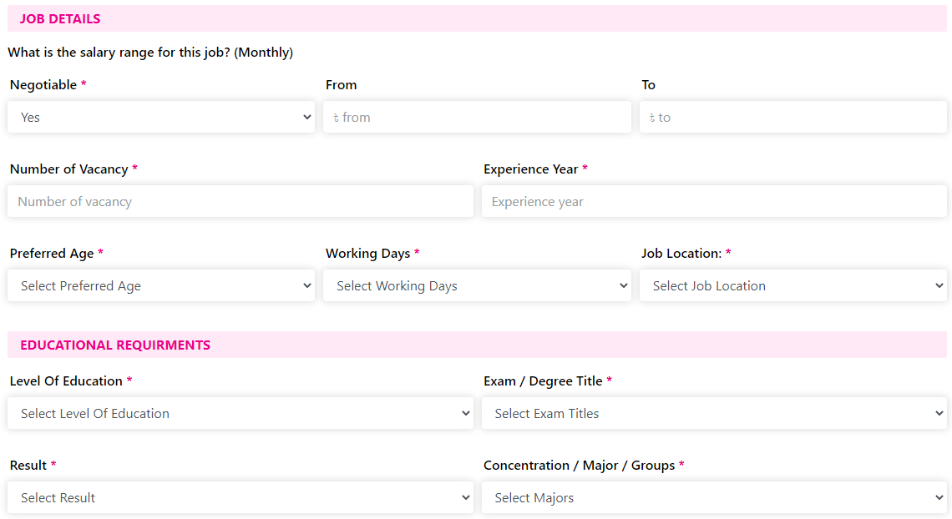

Figure 31 Post a Job Form details (3)

Figure 32 Post a Job Form details (2)

* User have to enter relevant information in the form to post a job
* After posting a new job external employee will need approval from admin

#### Post a Job form details (External Employee)

|  |  |
| --- | --- |
| **Field Name/Icon/Button** | **Description** |
| ***Job Title*** | *Title of the job post* |
| ***Job Type*** | *Type of the job post* |
| ***Job Level*** | *Level of the job post* |
| ***Category*** | *Relevant category of the job post* |
| ***Sub-category*** | *Relevant sub category of the job post* |
| ***Job description/ Responsibility*** | *Responsibility , description of the job post* |
| ***Negotiable*** | *Salary negotiation status of the job post* |
| ***From*** | *Salary Range* |
| ***To*** | *Salary Range* |
| ***Number of Vacancy*** | *Number of the total vacancy of the relevant job post* |
| ***Experience Year*** | *Required experience for the job post* |
| ***Preferred Age*** | *Preferred age for the job post* |
| ***Working Days*** | *Number of the working days of the job post* |
| ***Job Locaations*** | *Locations of the job post* |
| ***Level Of Education*** | *Level of education for the job post* |
| ***Exam / Degree Title*** | *Degree title for the job post* |
| ***Result*** | *Required result for the job post* |
| ***Concentration / Major / Group*** | *Required Major / Concentration/ Group for the job post* |
| ***Additional Information*** | *Required Additional information for the job post* |
| ***Application Deadline*** | *Deadline of the job post* |
| ***Publish Post*** | *Click to confirm all the job publish.* |
| ***Close*** | *Click to close the form* |

Table 23 Post a job form details

### Manage Jobs

Figure 33 All jobs page

* Clicking on Manage Jobs user will be redirect to Manage Jobs menu;
* Here user will find following column, buttons:
* Job title
* Vacancy
* Total Applicants
* Shortlist (column)
* Application Deadline
* Acceptance Status
* Action
* Shortlisted (button)
* Review

|  |  |
| --- | --- |
| **Column / Field Name/Icon/Button** | **Description** |
| ***Job title*** | Title of the job posts |
| ***Vacancy*** | Offered vacancy for the job post |
| ***Total Applicants*** | Total number of applicants in the Job |
| ***Shortlist*** | Total number of shortlisted candidate for the job |
| ***Application Deadline*** | Deadline for applying the job post |
| ***Job Status*** | Active/ Inactive status of the job post |
| ***Acceptance Status*** | Status of the acceptance of the posted job in the applications |
| ***Action*** | To edit any information about job post |
| ***Edit*** | For updating any information about a job post |

Table 24 Manage Jobs Page Details

#### Edit Job

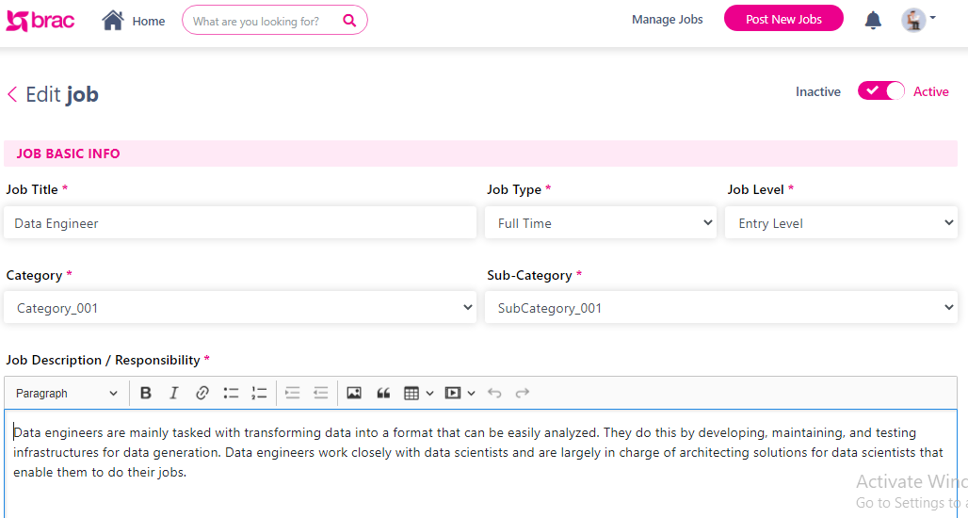

Figure 34 Edit Job form details (1)

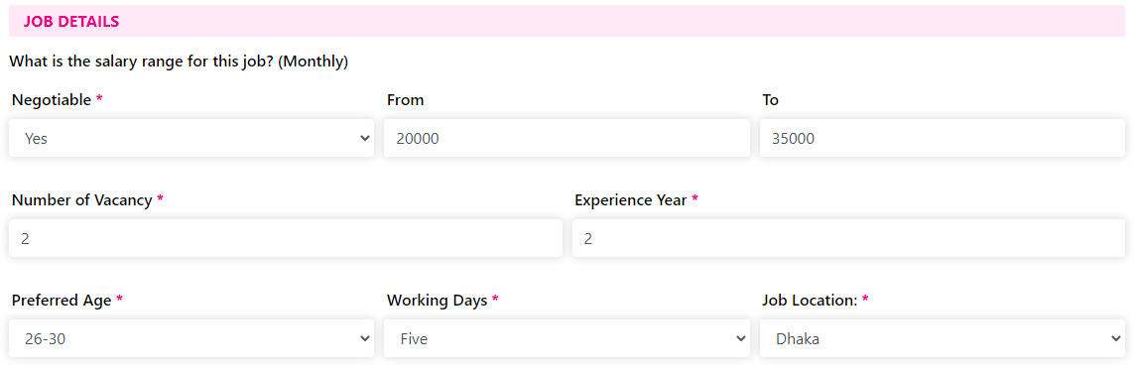

Figure 35 Edit job Form details (2)

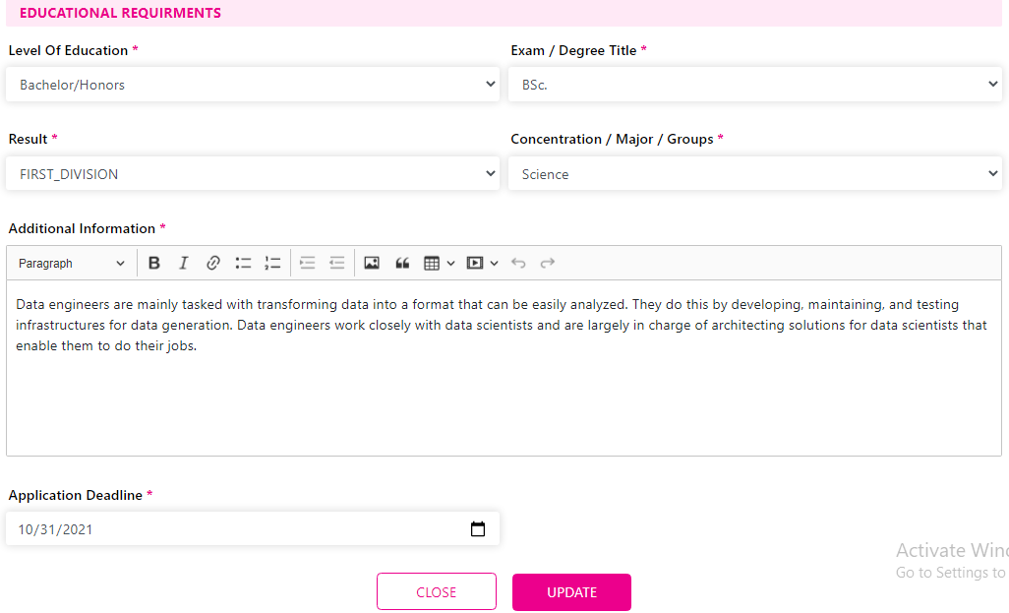

Figure 36 Edit job Form details (3)

* Here Employee surer will be able to update relevant job post information;

User will find following fields buttons in form:

Table 25 Edit job form details

|  |  |
| --- | --- |
| **Field Name/Icon/Button** | **Description** |
| **Job Title** | Title of the job post |
| **Job Type** | Type of the job post |
| **Job Level** | Level of the job post |
| **Category** | Relevant category of the job post |
| **Sub-category** | Relevant sub category of the job post |
| **Job description/ Responsibility** | Responsibility , description of the job post |
| **Negotiable** | Salary negotiation status of the job post |
| **From** | Salary Range |
| **To** | Salary Range |
| **Number of Vacancy** | Number of the total vacancy of the relevant job post |
| **Experience Year** | Required experience for the job post |
| **Preferred Age** | Preferred age for the job post |
| **Working Days** | Number of the working days of the job post |
| **Job Locaations** | Locations of the job post |
| **Level Of Education** | Level of education for the job post |
| **Exam / Degree Title** | Degree title for the job post |
| **Result** | Required result for the job post |
| **Concentration / Major / Group** | Required Major / Concentration/ Group for the job post |
| **Additional Information** | Required Additional information for the job post |
| **Application Deadline** | Deadline of the job post |
| **Close** | Click to close the form |
| **Update** | Click to confirm all the update and publish. |
| **Active / Inactive** | Click to set or inactive status of the job post form |

#### Shortlisted

Figure 37 Shortlisted Page Details

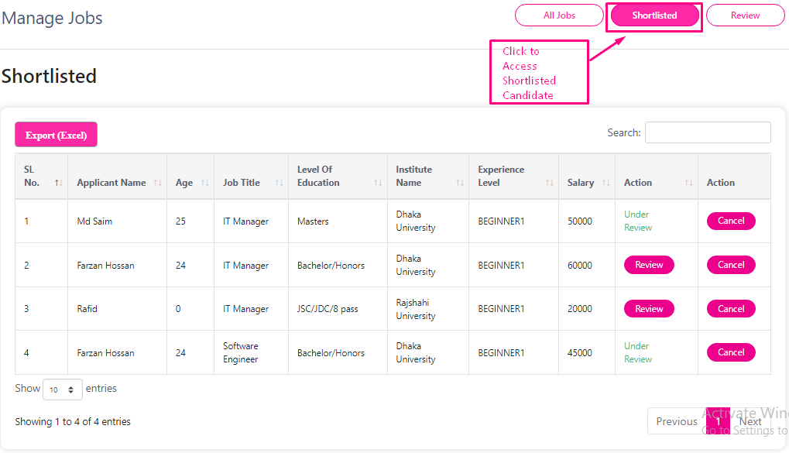

* Clicking on shortlisted employee user will redirected all the Shortlisted candidate list.
* Here employee user will find all the following column, button that are on the Shortlisted page:

Table 26 Shortlisted Column Details

|  |  |
| --- | --- |
| **Column /Field Name/Icon/Button** | **Description** |
| Applicant Name | Name of the job applicant |
| Age | Age of the job applicant |
| Job Title | Title of the job post |
| Level of Education | Education level for the job post |
| Institute Name | Name of the institute |
| Experience level | Level of the experience |
| Salary | Expected salary of the applicant |
| Action | Relevant action for the participant |
| Action | Cancelation of the Shortlisting of the participant |

#### Review

Figure 38 Review Page Details

* Clicking on Review button user will redirect to all the reviewed candidate.
* Here user will find following column button from the Review page

Table 27 Review page column details

|  |  |
| --- | --- |
| **Column /Field Name/Icon/Button** | **Description** |
| Applicant Name | Name of the job applicant |
| Age | Age of the job applicant |
| Job Title | Title of the job post |
| Level of Education | Education level for the job post |
| Institute Name | Name of the institute |
| Experience level | Level of the experience |
| Salary | Expected salary of the applicant |
| Action | Relevant action for the participant |
| Action | Cancel action for any participant |

Table 28 Manage Jobs page Details

|  |  |
| --- | --- |
| **Field Name/Icon/Button** | **Description** |
| **Export (Excel)** | Click to download excel report of this page; |
|  | Enables admin to search for any keyword; |
|  | User can go back and forth of pages by clicking Next/Previous buttons. |
|  | User can decide to view the number of entries of total skills from this drop down list at the bottom left corner of this page. |
|  | Click to see the response details; |

### View profile (External employee)

Figure 39 Dashboard details

* Clicking on View Profile button employee will be able to see the user profile.

#### Account Information

Figure 40 Account Information form details

* Here user will be able to access all the account related information.
* User will be able to update following information:
* Account information
* Account Information Details
* Contact
* Photo

Table 29 Account Information Form Details

|  |  |
| --- | --- |
| **Field Name/Icon/Button** | **Description** |
| Account Information | User will find all the profile details of the employee. |
| Account Information Details | Company Details information. |
| Contact | Contact number of the employee user. |
| Photo | Photograph of the user . |

#### Account Information Details

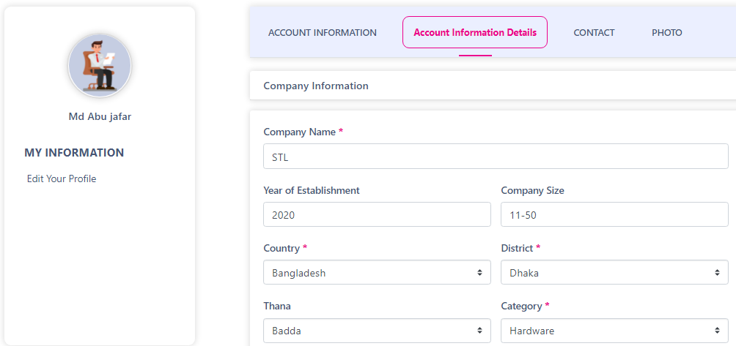

Figure 41 Company Information Form Details (1)

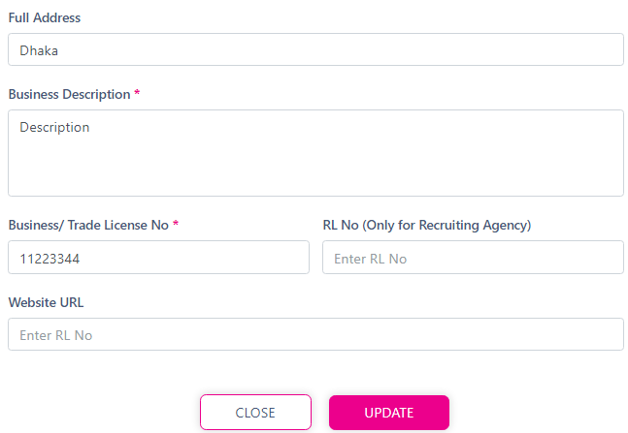

Figure 42 (Company Information Form Details (2))

* Here Employee user will be able to update all the Company related information.

User will find following filed and button on the page:

Table 30 Company Information Form details

|  |  |
| --- | --- |
| **Field Name/Icon/Button** | **Description** |
| Company Name | User can update the Company name form here |
| Year of Establishment | Company establishment year |
| Company Size | Size of the company |
| Country | Relevant country of the company |
| District | Relevant district of the company |
| Thana | Relevant Thana of the company |
| Category | Relevant Category of the company |
| Full address | Relevant Address of the company |
| Business Description | Description of the business of the company |
| Business/ Trade License No | Trade license No of the company |
| Rl No | Relevant RL No of the company |
| Website URL | Website URL of the company |
| Update | User can click to update the information |
| Close | User can click to close the form |

#### Contact

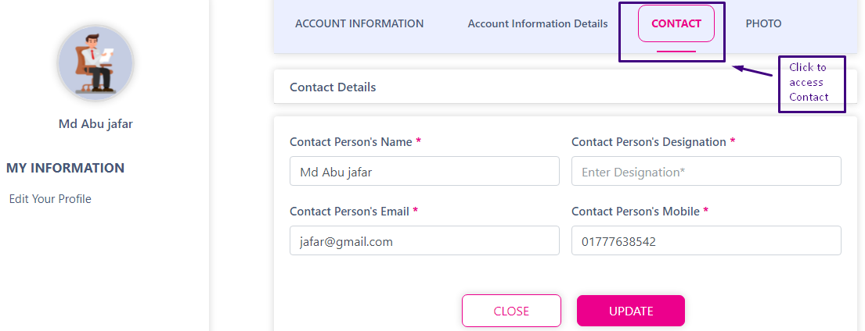Figure 43 Contact Details Form

* Clicking on Contact user will be redirected to contact details page
* Here user will find following fields and buttons:

Table 31 Contact Information Details’

|  |  |
| --- | --- |
| **Field Name/Icon/Button** | **Description** |
| Contact Persons Name | Name of the Contact persons |
| Contact persons designation | Designation of the contact person |
| Contact person Email | Email address of the contact person |
| Contact Persons Mobile | Mobile no. of the contact person |
| Update | Clicking on update button user will be able to update the information |
| Close | Clicking on close button the form will be closed |

#### Photo

Figure 44 Photo upload page details

* Clicking on Photo menu user will be redirected to photo update page.
* Here user will find following buttons:
* Choose file
* Update Photo

Table 32 Image Upload Field Details

|  |  |
| --- | --- |
| **Field Name/Icon/Button** | **Description** |
| Choose File | Clicking on choose file user will be choose file from the device |
| Update Photo | Clicking on this button user will be able to upload and update a photo |

## Internal Employer Dashboard

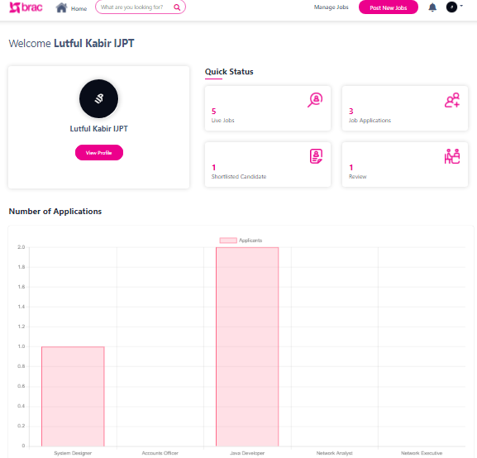

Figure 45 Internal Employee Dishoard

* This is the dashboard for an Internal employer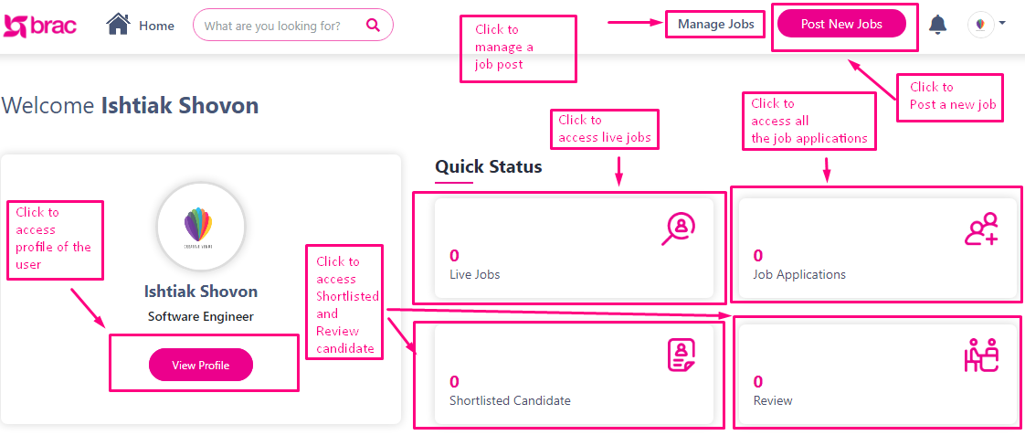

Figure 46 Internal Employee Dashboard

Table 33 Dashboard Details

|  |  |
| --- | --- |
| **Field Name/Icon/Button** | **Description** |
| ***Live Jobs*** | Here user will find list of all posted job list which are live at that moment |
| ***Shortlisted candidate*** | Here user will find listed candidate |
| ***Review*** | Here user will find listed review |
| ***View profile*** | Here user will find the user profile details |

* Internal Employee user will get all the privileges and facilities that are available for External Employee user;
* There will be few more privileges available for the internal employee user.

### Chart view of number of job applications

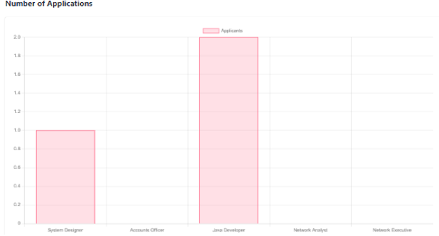

Figure 47 chart wise details of job posts vs job applicants

* The employers can view the chart wise details of job posts vs job applicants

### Post New Job (Internal Employee)

Figure 48 Internal Employee Dashboard

* Clicking on Post New jobs user will be redirect to Post a Job form

#### Post a Job form (Internal Employee)

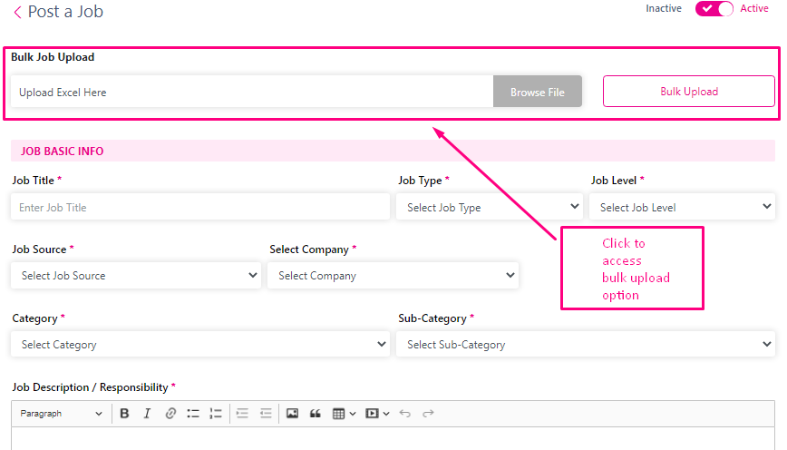

Figure 49 Post a Job form Details (Internal Employee) (1)

* For post a new job internal employee user will get an extra privileges of uploading bulk file option

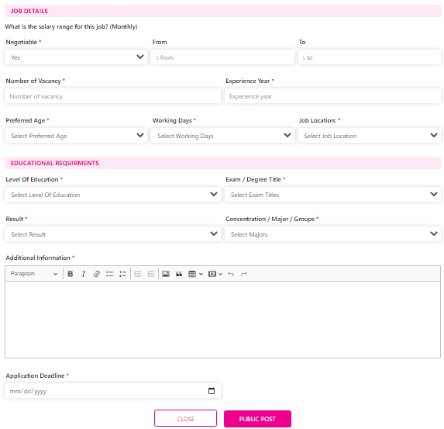Figure 50 Post a Job form Details (Internal Employee) (2)

* To post a new job internal employee user will get all the similar privileges as External Employee.
* Internal employee user won’t be needed any approval request to post a job.

Here user will find following fields, sections, and buttons:

Table 34 Post a Job form Details (Internal Employee

|  |  |
| --- | --- |
| **Field Name/Icon/Button** | **Description** |
| ***Bulk Upload*** | Clicking on this button user will be able to upload bulk file to fill up the form |
| ***Job Title*** | Title of the job post |
| ***Job Type*** | Type of the job post |
| ***Job Level*** | Level of the job post |
| ***Category*** | Relevant category of the job post |
| ***Sub-category*** | Relevant sub category of the job post |
| ***Job description/ Responsibility*** | Responsibility , description of the job post |
| ***Negotiable*** | Salary negotiation status of the job post |
| ***From*** | Salary Range |
| ***To*** | Salary Range |
| ***Number of Vacancy*** | Number of the total vacancy of the relevant job post |
| ***Experience Year*** | Required experience for the job post |
| ***Preferred Age*** | Preferred age for the job post |
| ***Working Days*** | Number of the working days of the job post |
| ***Job Locaations*** | Locations of the job post |
| ***Level Of Education*** | Level of education for the job post |
| ***Exam / Degree Title*** | Degree title for the job post |
| ***Result*** | Required result for the job post |
| ***Concentration / Major / Group*** | Required Major / Concentration/ Group for the job post |
| ***Additional Information*** | Required Additional information for the job post |
| ***Application Deadline*** | Deadline of the job post |
| ***Close*** | Click to close the form |
| ***Update*** | Click to confirm all the update and publish. |
| ***Active / Inactive*** | Click to set or inactive status of the job post form |

# Participant Module

In application’s 3rd phase participants will be able to:

* Access Available Jobs;
* Access Jobs for me;
* View applied jobs;
* Shortlist jobs
* View online applications
* Job Feedback;
* Section for hot jobs ;

Including above, all the other correlated features are dissected and described below.

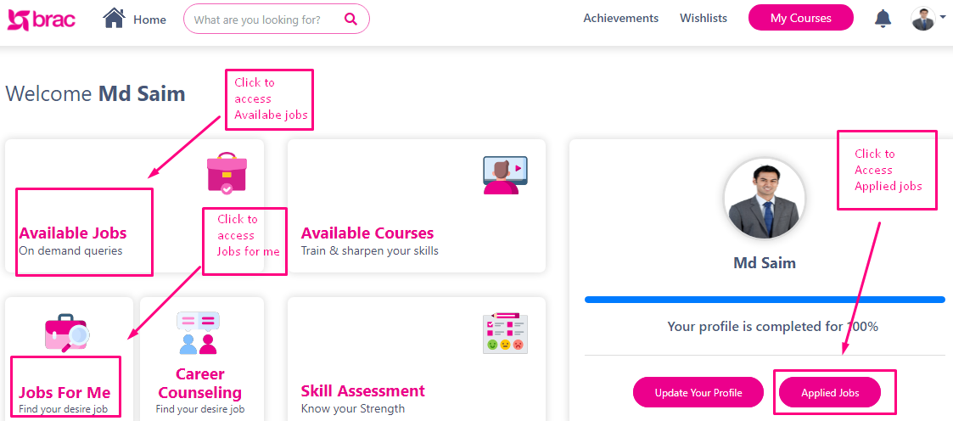

Figure 51 Participant Dashboard

## Available Jobs

Figure 52 All Jobs page

* Clicking on available jobs the participant user will be redirected to All Jobs page

Here participant user will find following fields and view cards:

Table 35 All Jobs Page details

|  |  |
| --- | --- |
| **Field Name/Icon/Button/ Viewcards** | **Description** |
| Select Category | Click to select relevant category to filter out the job posts |
| Select Sub-category | Click to select relevant sub-category to filter out the job posts |
| Job level | Click to select relevant job level to filter out the job posts |
| Search for experience year | Enter the relevant experience year |
| Preferred age | Select preferred age to filter out the job relevant job post |
| Search for any keywords | Enter relevant keywords to search job post |
| View cards | Click to see the job description |

### Job Description

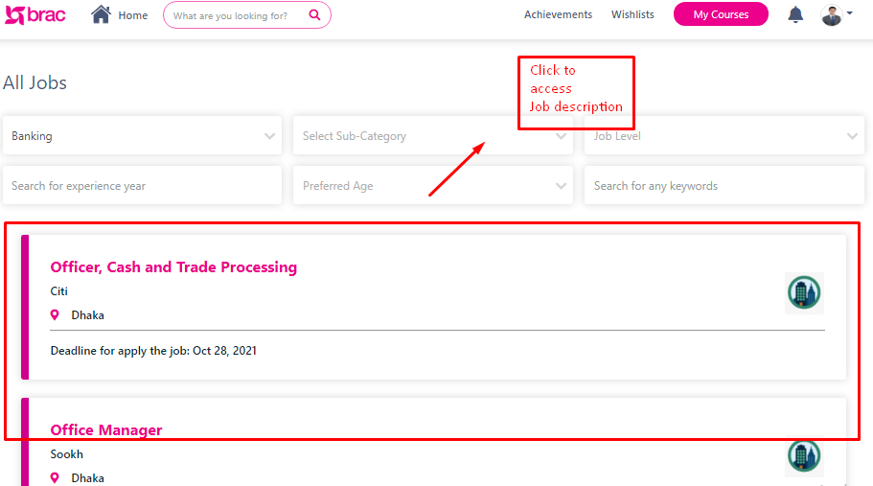

Figure 53 All Jobs page Detail’s

* Clicking on any of the Job Post view cards will be Redirected to relevant job description of that relevant job post

|  |  |
| --- | --- |
| **Field Name/Icon/Button** | **Description** |
| ***Select Category*** | Click to select relevant category to filter out the job posts |
| ***Select Sub-category*** | Click to select relevant sub-category to filter out the job posts |
| ***Job level*** | Click to select relevant job level to filter out the job posts |
| ***Search for year*** | Enter the relevant experience year |
| ***Preferred age*** | Select preferred age to filter out the job relevant job post |
| ***Search for any keywords*** | Enter relevant keywords to search job post |
| ***View cards*** | Click to see the job description |

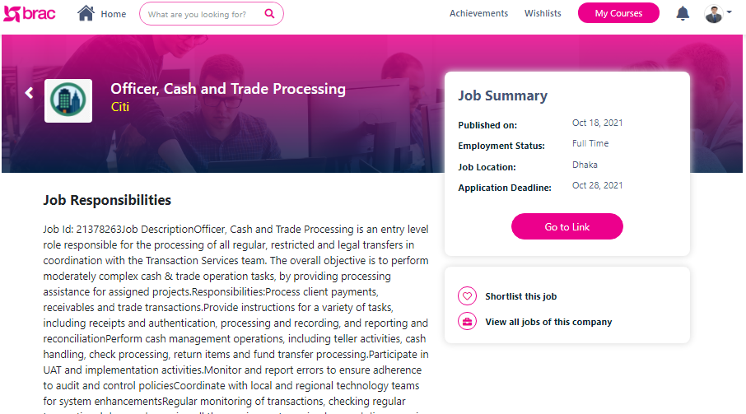

Figure 54 Job Descriptions Page (1)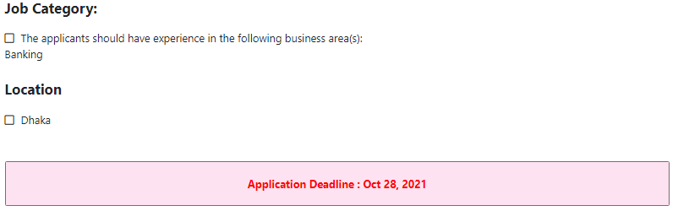

Figure 55 Job Descriptions Page (2)

* Here admin will find all the details about the relevant job post.

On the job description page user will find following this button and:

Table 36 Job Descriptions Page details

|  |  |
| --- | --- |
| **Field Name/Icon/Button** | **Description** |
| Job Responsibilities | Description and responsibilities about the posted job |
| Job Summary | Summary(published date , status about the job , job location, application deadline) about the job post |
| Go to Link | Clicking on this button user will redirect to other relevant job posting portal |
| Apply | Click to apply at job post |
| Short list this job | Click to shortlist the relevant job post |
| View all jobs of the company | Click to view all the job post of that company |
| Job category | Relevant category of that job post |
| Location | Location of that job post |
| Application Deadline view card | Last date for applying on that job post |

## Jobs for Me

Figure 56 Jobs For Me page

* Clicking on Jobs for me view cards dashboard user will redirect to Job for me Page.
* Here user will find all the user desired job post.

Here user will find following fields and view cards:

Table 37 Jobs for me page details

|  |  |
| --- | --- |
| **Field Name/Icon/Button** | **Description** |
| Select Category | Click to select relevant category to filter out the job posts |
| Select Sub-category | Click to select relevant sub-category to filter out the job posts |
| Job level | Click to select relevant job level to filter out the job posts |
| Search for year | Enter the relevant experience year |
| Preferred age | Select preferred age to filter out the job relevant job post |
| Search for any keywords | Enter relevant keywords to search job post |
| View cards | Click to see the job description |

## Applied Jobs

Figure 57 Online Applications Page Details

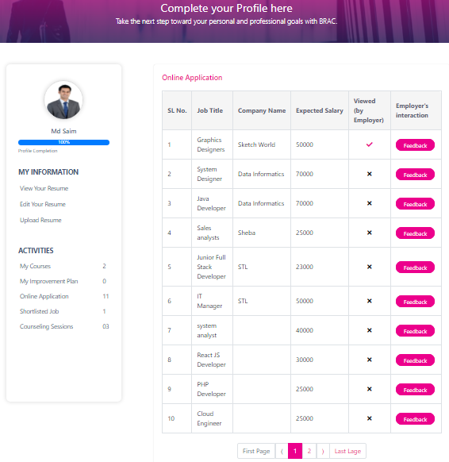

* Clicking on applied job post user will be redirect to Online Application page.
* Here user will find all the details about participants applied jobs.

User will find following columns, buttons and section:

Table 38 Online Applications Column Details

|  |  |
| --- | --- |
| **Column / Field Name/Icon/Button** | **Description** |
| Job Title | Title of the job post |
| Company Name | Name of the company. |
| Expected Salary | Expected salary by the applied participant |
| Viewed (by the employer) | Employer viewing status of the participant |
| Employers Interaction | Clicking on this button participant will be able to give feed about the relevant Job post |
| Activities | In this section participant will find about the shortlisted jobs |

Table 39 Online Applications Page Details

|  |  |
| --- | --- |
| **Field Name/Icon/Button** | **Description** |
|  | User can go back and forth of pages by clicking Next/Previous buttons. |

### Perform Job Feedback

* 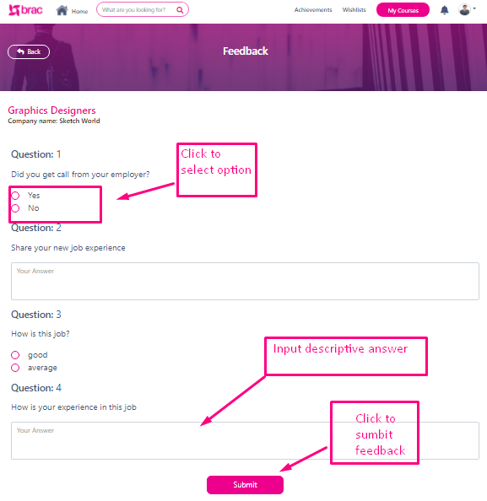Participants will be able to provide job feedback from here

Figure 58 Job Feedback Form

Figure 59 Job Feedback Form

### Shortlisted Job

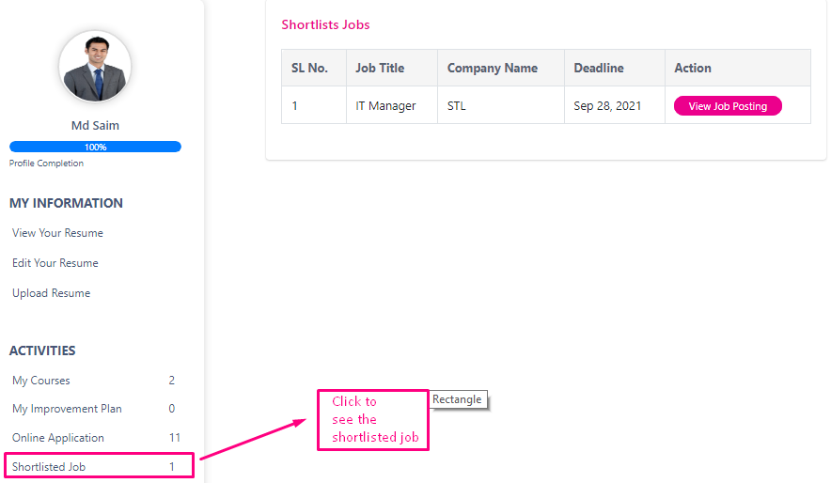

Figure 60 Shortlists Jobs Page Details

* Clicking on shortlisted job user will be redirected to shortlists jobs page.

Here user will find following column and buttons:

Table 40 Shortlists Jobs page details

|  |  |
| --- | --- |
| **Column/Field Name/Icon/Button** | **Description** |
| Job Title | Title of the job post |
| Company Name | Name of the company. |
| Deadline | Deadline for applying on the relevant job |
| Actions | Action button for viewing job posting |
| View Job posting | Clicking on this button will redirect to job description page |

## Hot Jobs

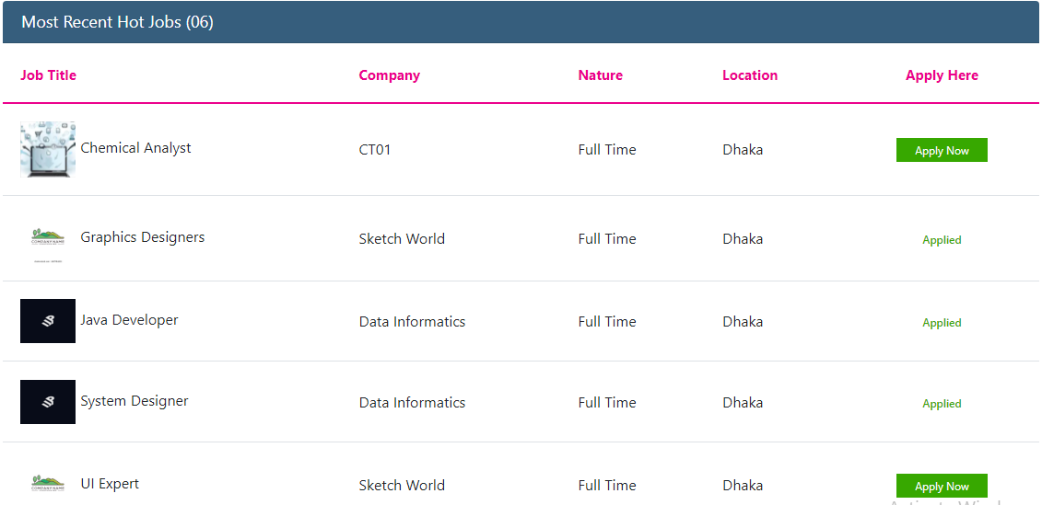

Figure 61 Hot Jobs Page

* On the Participant dashboard user will find all Hots jobs

Here user will find the following Column:

Table 41 Hot Jobs Column Details

|  |  |
| --- | --- |
| Column/Field Name/Icon/Button | **Description** |
| **Job Title** | Title of the job post |
| **Company** | Name of the company. |
| **Nature** | Nature of the relevant job post p |
| **Locations** | Locations of the relevant job post |
| **Apply Here** | In this column user will find Apply Now button to any job post |
| **Apply Now** | Clicking on the button user will be able to apply ay job post form the column |